**MYTHIC**

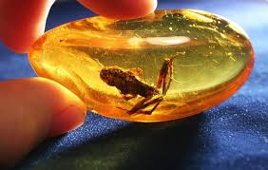

**Name:** Dummy Diamond

**Brand:**  Harry Winston

**Model#:** 003

**Color: ­** Green

**Price: $600k**